**A**

1. **Alegeti care este rezultatul corect pentru urmatorul select:**

Select First_name as Name

,Email_addr as Email

,parent_id

From AD_Student_Details

Where parent_id >=620

And parent_id <=630

And email_addr is not null

Order by 1, 2 desc;

a)

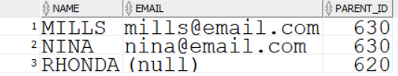

b)

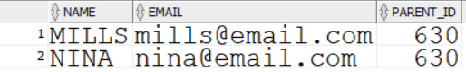

c)

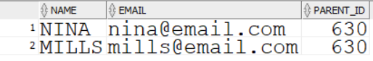

d) 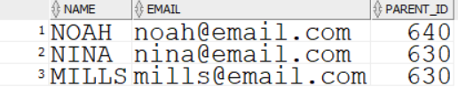

**2) Identificati erorile in selectul de mai jos si scrieti varianta corecta:**

Select faculty_id

,login_date "login"

,login_time as log time

,details

from AD_Faculty_login_Details;

Where log time is null

or login_time is not null;

1. **In baza datelor de mai jos “Departments” table, scrieti un select care ar afisa numele departamentului,manager_id,location_id pentru departamnetele care au manageri. Si location id este mai mare decit 1500.**

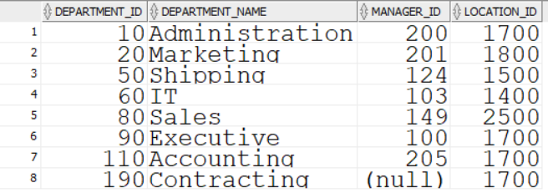

**B**

1. **Alegeti care este rezultatul corect pentru urmatorul select:**

Select course_name as "Course Name"

,Department_id as Department

,session_id

From AD_course_details

Where course_name like '%BIOLOGY%'

OR course_name like '%ACCOUNTING%'

Order by session_id desc, 1;

a)

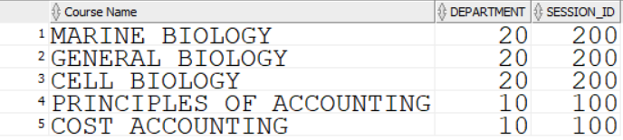

b)

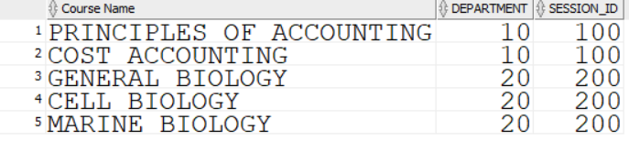

c) 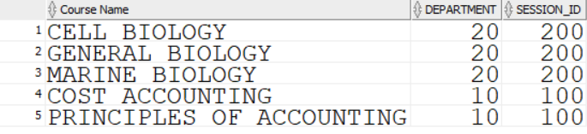

d) 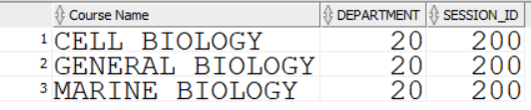

1. **Identificati erorile in selectul de mai jos,si scrieti varianta corecta**

Select student_id

,exam_id

,course_id as course id

,marks as points

from AD_exam_results

Order by 2,points desc

Where course id is not null;

1. **In baza datelor de mai jos “job_history” table, scrieti un select care ar afisa employee_id,Start_date,end_date, job_id pentru angajatii care au jobul “ST_Clerk” si AC_Account .**

